Guorun Huang, Project1 Report

Pattern Recognition and Computer Vision, 25Fall

(choose to use 3 travel days to adjust the ddl)

**1. Project Overview**

This project is a real-time face filter system built with OpenCV. It processes live camera input to apply effects like color adjustment, blurring, and edge detection. It also supports face detection, depth estimation, and a virtual sunglasses try-on feature. (The methods uesd are that the program reads each frame from the webcam and modifies pixel values or extracts features like edges and gradients.)

**2. Project Demonstration**

Below are screenshots and brief descriptions showing the system in action:

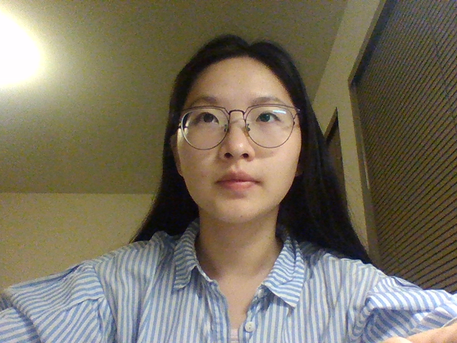

Figure 1: Original camera feed Shows the unprocessed video input from the webcam.

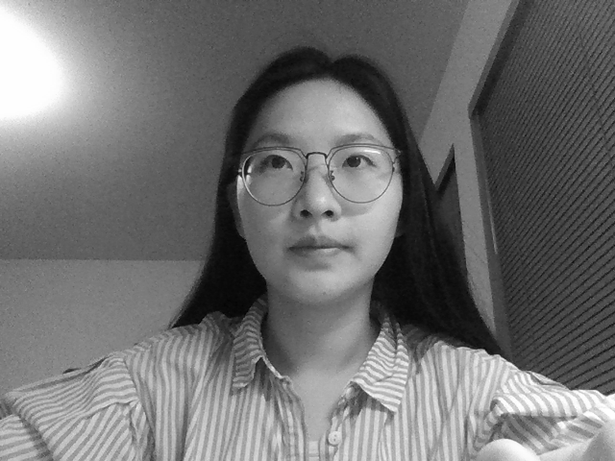

Figure 2: Grayscale image using cvtColor Demonstrates OpenCV’s built-in grayscale conversion.

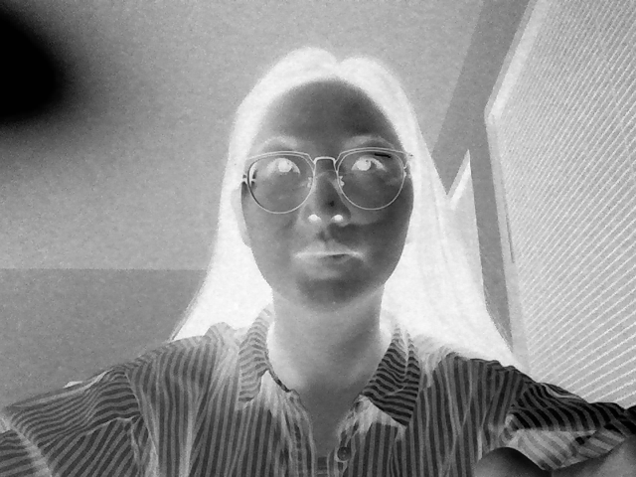

Figure 3: Custom grayscale image A manually computed grayscale version for comparison.

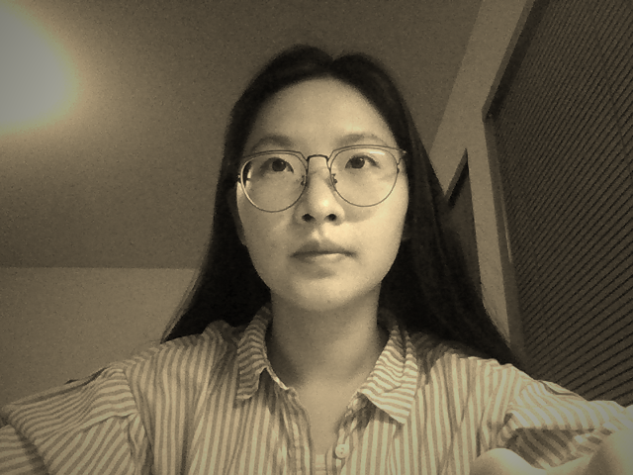

Figure 4: Brown filter result Applies a vintage-style color effect while preserving RGB structure.

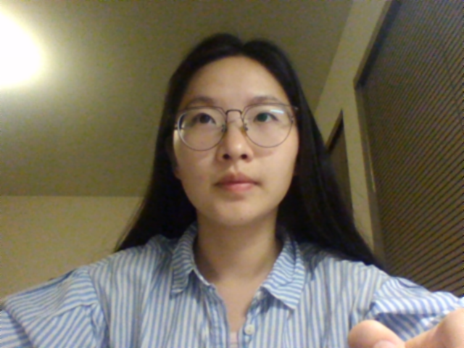

Figure 5: Blurred image Uses Gaussian blur to smooth the image.

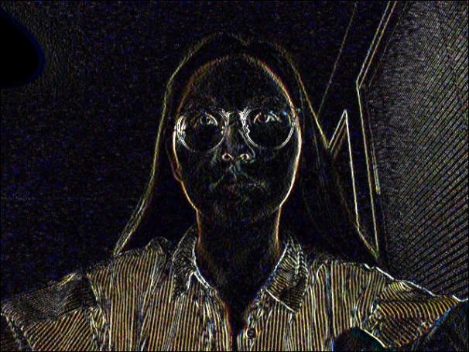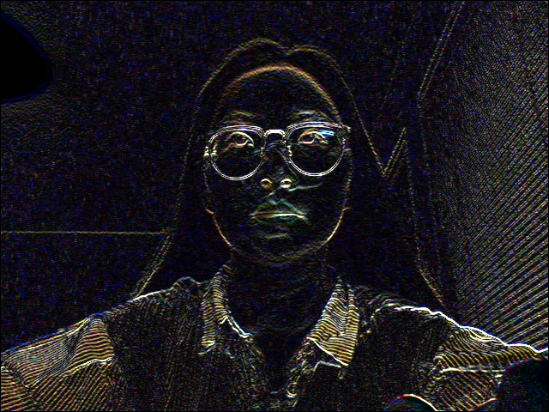

Figure 6: Edge detection Shows detected edges using a test image. Performance was improved by using separable kernels and direct pointer access instead of the at() method.

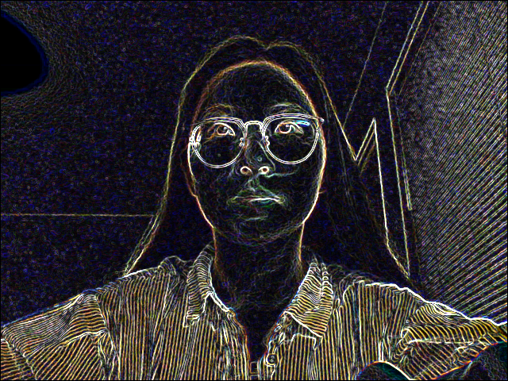

Figure 7: Gradient image Highlights directional changes in pixel intensity.

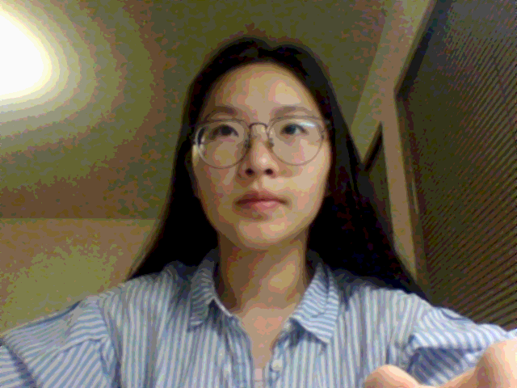

Figure 8: Blurred and quantized image Combines blur with color quantization for a stylized look.

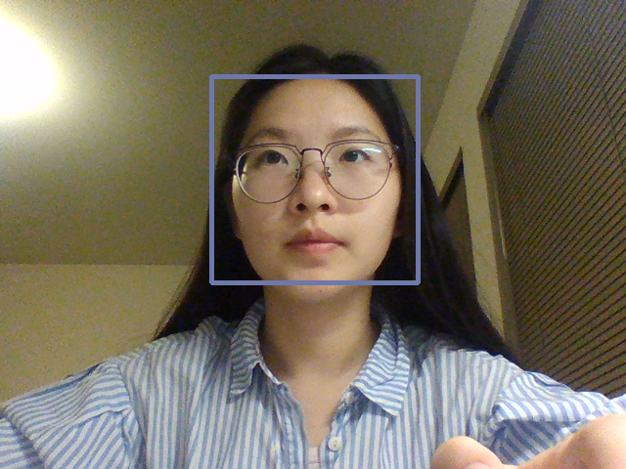

Figure 9: Detected faces from video stream Displays bounding boxes around detected faces.

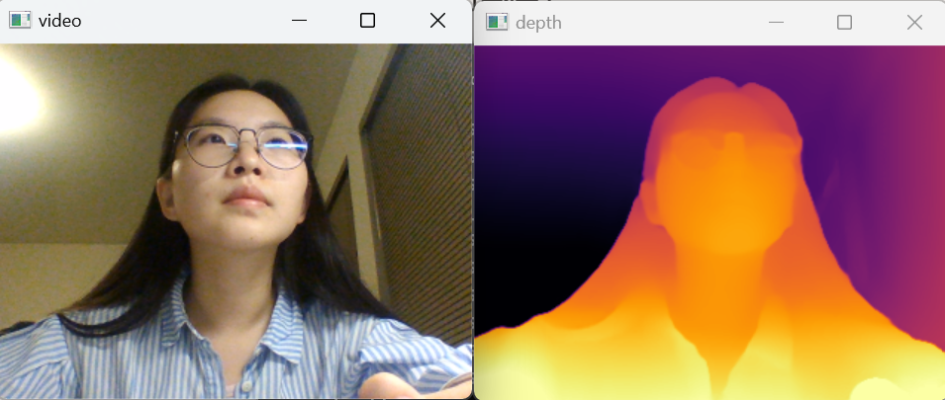

Figure 10: Depth map and filtered image Shows depth estimation and filtering based on depth values.

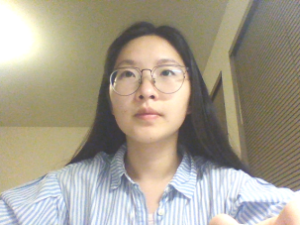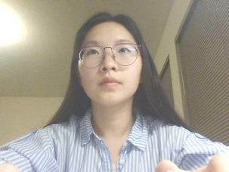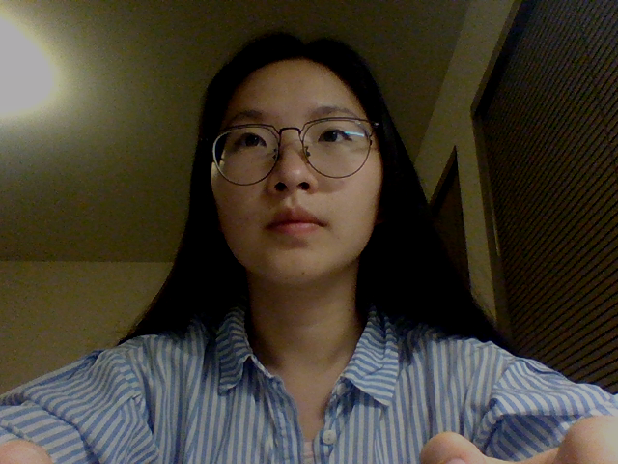

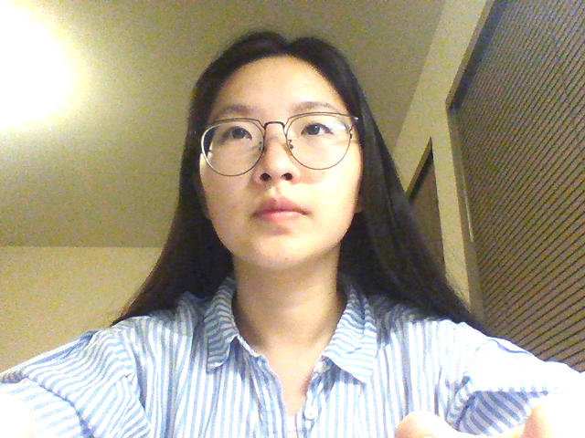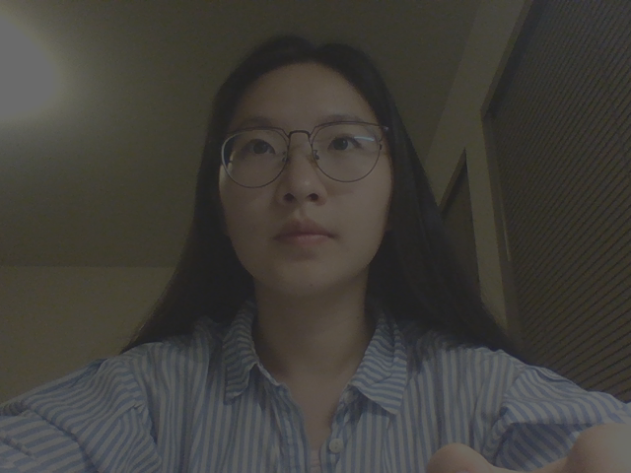

Figure 11: Brightness and contrast adjustment Applies global image enhancement.

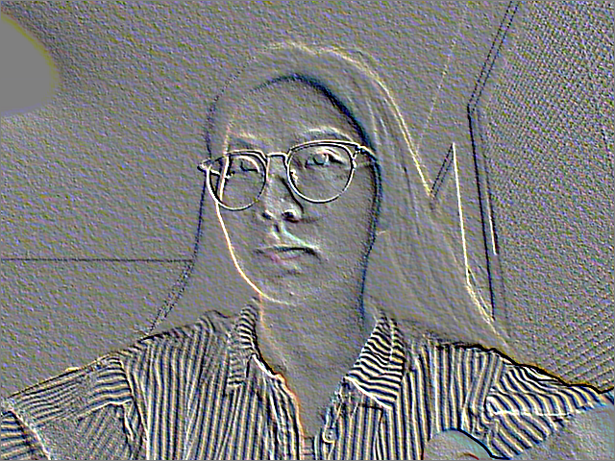

Figure 12: Emboss effect Adds a raised texture to the image.

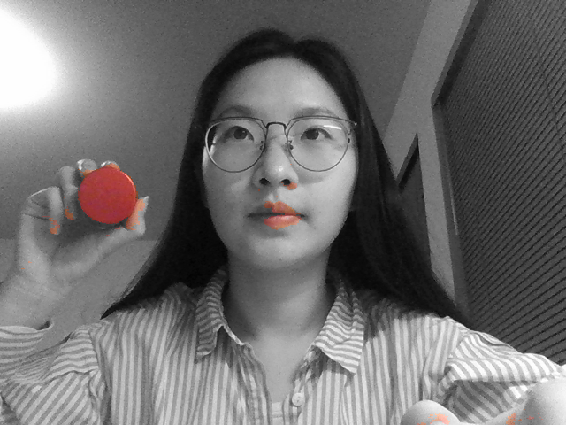

Figure 13: Strong color effect Applies bold color transformations.

**3. Extended Features**

One added feature is automatic eye detection with a sunglasses overlay. The sunglasses track the face’s movement and can be swapped out for different styles. Users can also save video clips, making it easy to preview how various sunglasses look in real time.

**4. Learning Reflections**

Through this project, I gained a deeper understanding of pixel processing in OpenCV, how to handle transparency channels, the mechanism of face detection (cascade classifiers), and methods of image overlay. I also learned how to control pixel ranges, debug effectively (such as checking the number of channels, returning useful error messages when problems occur, and adding cout prompts at key steps), and optimize the calculation of overlay positions.

Challenges I faced:  
Before starting, I saw recommendations on Reddit suggesting VS Code, as it is more flexible and supports more features than Visual Studio. So I chose VS Code. The setup process was not simple—I had to troubleshoot multiple errors before finally installing msys, GUI, and Qt libraries, and successfully compiling. However, in Task 11, I found it very difficult to integrate Depth Anything into VS Code. To solve this, I created a virtual environment inside the project folder, installed multiple .whl dependencies of onnx, and was able to call it successfully using Python.

In Task 11, I also tried to add a feature that would warn users when their face is too close to the camera, to help protect eyesight. But I ran into a problem: if I set the system to trigger an alert whenever the face is within the first 15% of depth, the alert would keep firing even when the person leaned back. This is because depth changes dynamically, so relative depth values remained small. A possible solution would be to calibrate with photos taken at fixed physical distances, though this is more complex. I may use this idea as my final project because it’s both challenging and interesting.

During the extended exercises, I experimented with making a “potato filter.” My goal was: in the original window, the background contains a face; in the processed window, a potato image (potato.png) replaces the face, with eyes and a mouth placed on it. As the face moves (up/down, left/right), the potato with facial features should also move accordingly. However, I found that OpenCV detects eyes as square regions, which is not suitable for this filter. In addition, the bounding boxes for the eyes and mouth often switched places. I tried installing Mediapipe for better face landmark detection, but my Python version did not support it. I then realized this project would be too time-consuming, so I switched to making a ghost-face filter. But I found that simply overlaying a ghost image rarely aligned well with the face, and it was difficult to adjust its size as the person moved closer or farther from the camera. Finally, I came up with the virtual sunglasses effect. This can also be replaced with a glasses frame, allowing users to instantly preview how a pair of glasses would look on their face using just a webcam, which has great economic potential.

**5. Acknowledgements**

Thanks to Professor Maxwell and the TAs for their guidance and support. I also referred to the official OpenCV documentation, Stack Overflow discussions, and various online tutorials throughout the project.